CYBERBULLYING DETECTION SYSTEM

Eugenia Gwaze; Wellington Makondo

Department of Software Engineering, School of Information Sciences and

Technology Harare Institute of Technology, Harare, Zimbabwe

eugwaze@gmail.com;wmakondo@hit.ac.zw
Abstract
Cyberbullying has become a concerning issue in online game chat rooms. To tackle this problem, I have propose a Cyberbullying Detection System that uses Sentiment Analysis to identify cyberbullying behaviour in English language chat rooms. The primary objective of this system is to create a safe and secure online gaming environment by analyzing chat room messages for sentiment and producing activity reports.The system architecture has been meticulously designed to perform unsupervised and temporal sentiment analysis on text messages. This enables the early detection of cyberbullying instances and prompt implementation of preventative measures. Moreover, the system has robust data security features such as key encryption and master signing mechanisms to safeguard user data. Overall, this system has the potential to significantly improve the safety and security of online game chat rooms by providing a strong defense against cyberbullying and ensuring the well-being of users in these virtual spaces.

Keywords: sentiment analysis ,Natural language processing, Machine learning, polarity score, profanity analysis, cyberbullying

I. INTRODUCTION
The surge of cyberbullying in online game chat rooms has become a major issue, requiring the development of effective strategies for detection and prevention. This thesis proposes a Cyberbullying Detection System that uses Sentiment Analysis to identify instances of cyberbullying in English language game chat rooms. The system's main objective is to establish a secure online gaming ecosystem by scrutinizing sentiments expressed in game chat rooms. The system generates comprehensive reports to promote a culture of safety and responsible interaction among users. The system's architecture has two critical functions: unsupervised sentiment analysis and temporal analysis of text messages. These capabilities allow the system to identify and predict instances of cyberbullying, taking prompt preventative measures to mitigate harm and foster a respectful environment. To safeguard user data, the system has robust data security features such as key encryption and master signing mechanisms that protect user information from potential threats or breaches.
In summary, this visionary Cyberbullying Detection System has the potential to elevate safety and security standards within online game chat rooms, serving as a significant defense against cyberbullying. By doing so, this project takes a step towards preserving the psychological and emotional well-being of users in virtual spaces, highlighting the importance of this pioneering endeavour in the digital landscape.

II. PROBLEM STATEMENT
This project aims to create a unique Cyberbullying Detection System that can identify instances of cyberbullying in the English language. This system has the potential to significantly impact the safety and well-being of users in online game chat rooms. The main purpose of this system is to act as a vigilant guardian, constantly monitoring and responding to cyberbullying incidents. With the help of advanced technological tools, such as sentiment analysis and real-time monitoring, it can provide a comprehensive shield against harmful online behaviours.
In the virtual world, anonymity and distance can often lead to fear and intimidation. This system aims to create a safe and secure environment for users to interact in, free from any such fears. It seeks to enrich their online gaming experience by fostering an environment where they can interact without any fear of cyberbullying.

III. RELATED WORK
There are various content filtering software systems available in the market that can be used by parents to monitor their children's social media activity and help detect and prevent cyberbullying. Some of the popular software systems include BullyBlocker, SafeChat, Facebook WatchDog, Rethink, Bark, and Bull Stop. These software systems are specifically designed to filter and analyze the online content to ensure the safety of children from online harassment and cyberbullying.

Pocket Guardian
The Pocket Guardian Application is a mobile app that was created for iOS and Android by Pocket Guardian LLC (Llc 2018). For Android devices, the Google Play Store offers the application for download, and for iOS devices, iTunes offers the same. Parents can monitor their children's social media accounts and cell phones without violating their privacy by using the Pocket Guardian program. This app will only notify parents in the event that they find evidence of sexual or cyberbullying on their children's cell phone.

SafeChat
SafeChat is a software tool that helps protect children's communication on Facebook from explicit messages. The creators of SafeChat have developed a powerful model that uses natural language processing algorithms to identify specific words and phrases that are commonly associated with explicit content.The SafeChat model works by analyzing the text of Facebook messages and searching for keywords and phrases that may indicate the presence of explicit content. If the model detects any such content, it immediately blocks the message before it can be delivered to the recipient.
to ensure that they can communicate safely and securely on Facebook.

Bully Alert
The Bully Alert app is a mobile application developed by the CU Cyber Safety Lab as a research project for the University of Colorado Boulder (Lab 2018). This app is designed for Android and can be downloaded from the Google Play Store. It allows anyone to monitor another person's social media account and receive notifications if cyberbullying is detected on that account. Currently, the app only works with Instagram accounts. To use it, simply input the Instagram profile name of the account you want to monitor into the app. The app will then begin monitoring the profile and send a notification if any cyberbullying occurs on that account. The notification will provide details and context about the message being sent from that Instagram profile.

FacebookWatchDog
Facebook WatchDog is a software tool designed to detect threats and cyberbullying on social media. Its creators have developed a powerful system that uses social media analytics, image analysis, and text mining to identify potential threats and cyberbullying on platforms like Facebook.The tool analyzes social media activity by looking for patterns of behavior that may indicate the presence of a threat or instance of cyberbullying. This includes analyzing posts and comments for specific keywords and phrases that are commonly associated with threatening behavior or cyberbullying.

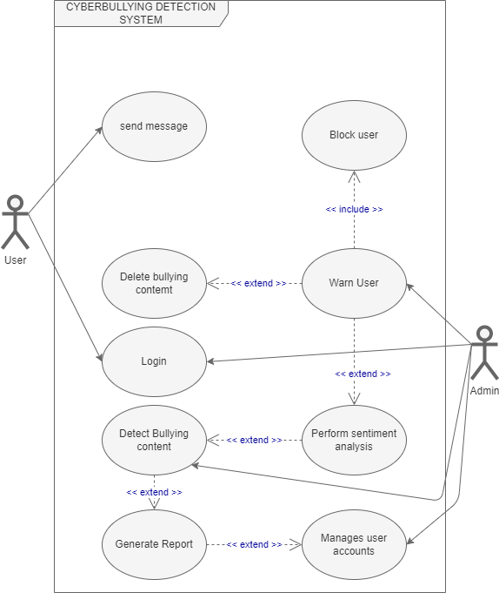
Figure 1: Use case definition of the provides a high-level overview of the interactions and functionalities of the cyberbullying detection system.

IV.SOLUTION
The proposed system is aimed at detecting cyberbullying through sentiment analysis, making use of machine learning technology. The system will consist of three main modules: the machine learning model, the chat module (based on Discord), and the admin module for reports and database management
To realize this ambitious goal, the following precise objectives have been delineated:
- To perform sentiment analysis on text messages to predict cyberbullying in game chatrooms
- To notify the Admnistrator when cyberbullying text is detected.
- To block and delete cyberbullying text
- To generate a report of the activites in the system
The proposed system would operate in the following manner:
1. The Admin creates a game room server and a chatbot that automatically listens and monitors every activity in the server. The bot API is then assigned to our system.
2. The bot forwards every message to the system, which analyzes the polarity of the message and its intent. If both are negative, the system prompts the bot to delete the messages and record the message and user of the message that was flagged and deleted into the database.
3. The system generates reports that display all the flagged messages, their users, and timeframes.

A. Features of the System
The system's core features encompass:
- Sentiment analysis within online gaming chat rooms.
- Real-time reporting and monitoring of user interactions.
- Unsupervised and temporal sentiment analysis for cyberbullying prediction.
B. Benefits of the System
The proposed system offers the following benefits:
- Comprehensive reports detailing user activities within the system.
- Real-time reporting and monitoring of user interactions.
- Unsupervised and temporal sentiment analysis for cyberbullying prediction.
- Robust data security mechanisms to safeguard user information.
C. Solution Architecture
The cyberbullying detection system aims to identify and flag instances of cyberbullying in online content.
The system utilizes a combination of Naive Bayes, profanity analysis, and TextBlob analysis to achieve accurate and efficient detection. The following is a high-level solution architecture for the system:
- Data Collection: This phase is for gathering a diverse dataset consisting of online content (e.g., social media posts, comments, messages) that includes both cyberbullying and non-cyberbullying instances.
- Preprocessing: Cleaning the collected data by removing irrelevant information, such as URLs, emojis, and special characters and spliting the preprocessed dataset into training and testing sets.
- Naive Bayes Classifier: Naive Bayes algorithm to calculates the probabilities of an instance belonging to the cyberbullying or non-cyberbullying class.
- Profanity Analysis: Filters the data that can identify offensive and inappropriate language commonly associated with cyberbullying.
- TextBlob Analysis: Utilizes TextBlob, a Python library for natural language processing, to perform sentiment analysis and subjectivity analysis on the text. Sentiment analysis determines the polarity (positive, negative, or neutral) of the text.
- Aggregation and Decision Making: Combine the outputs from Naive Bayes, profanity analysis, and TextBlob analysis to arrive at a final decision.
Integration and Deployment: Integrating the cyberbullying detection system on the Discord server where there is a bot that listens to every text message that is sent in real time.

Architectural Design
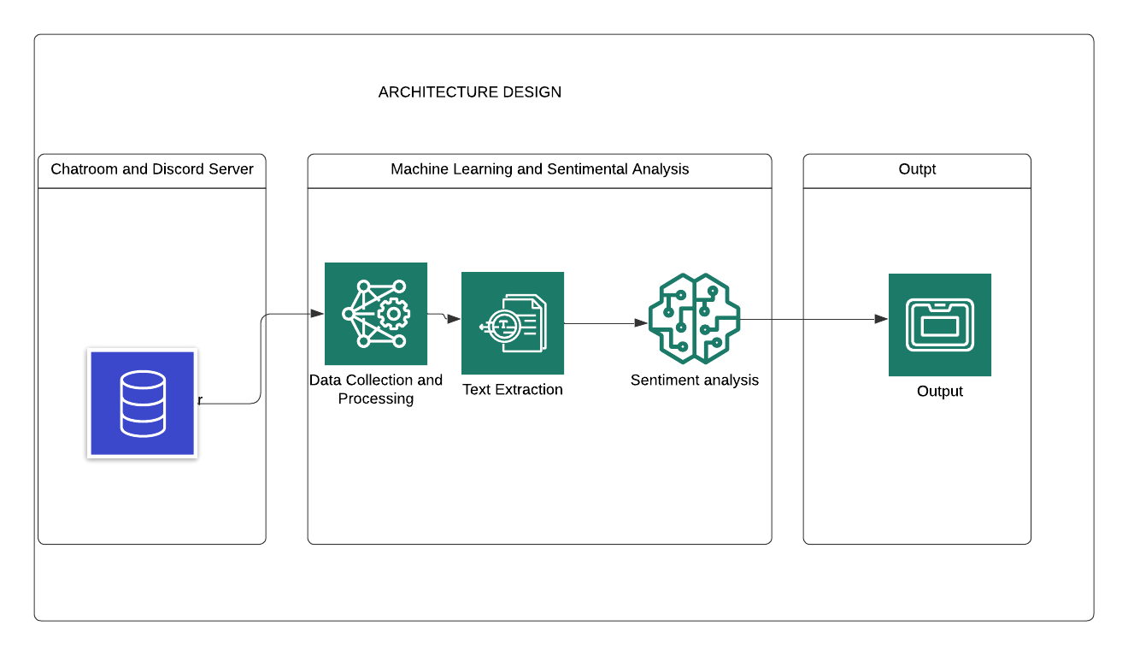
This architectural design provides a high-level overview of the main components and their interactions in the cyberbullying detection system

RESULTS AND FUTURE WORKS

TABLE OF RESULTS
Domain | Expected Results | Actual Results
Functional Testing | • The system modules should function as expected.  •The system should be easily accessible and user friendly.  •Error messages should be displayed on the system. | As expected
Integration Testing | All the integrated modules should work  together flawlessly. | As expected
System Testing | All the components of the system should  function properly. | As expected
Acceptance Testing | The system should meet user requirements and system objectives. | As expected

Model Performance
Data Overview
- Dataset: Messages, 1,000 labelled as cyberbullying.
- Train-Test Split: 7,000 training, 3,000 testing.
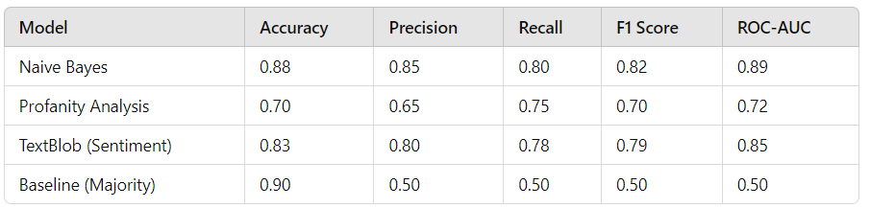
Error Analysis
- False Positives: Commonly found in sarcastic comments without explicit profanity.
- False Negatives: Often occur in subtle cyberbullying instances using indirect language.

Future Works
Some potential areas of future work for the system could include:
1. Expanding the system to be multilingual that is detecting cyberbullying in many languages
2. Multimodal Analysis: Incorporate multimodal analysis techniques that combine text analysis with other modalities such as images, videos, and audio.
3. Collaboration with Online Platforms: Collaborate with social media platforms and online communities to integrate the cyberbullying detection system into their existing moderation systems.
CONCLUSION
In conclusion, the "Cyberbullying Detection System" project successfully developed an automated system capable of detecting cyberbullying instances in online platforms. The system's deployment has contributed to creating a safer online environment by promptly identifying and addressing instances of cyberbullying, thus helping protect individuals from online harassment and abuse.

ACKNOWLEDGEMENT
Firstly, I would like to thank God for taking me this far. I am grateful for the gift of life, good health and all the resources that I used to complete this project. Then, I specifically want to acknowledge Mr Makondo, my supervisor for the tremendous support, useful comments, remarks, feedback and engagement through the learning process of this capstone research project.

I would like to express my sincere gratitude to Mrs Chibaya , Mr. Mukosera, Miss Amos, Mr. Manjoro, Miss Zindove and Mr. Chiworera and for their unending support. It is the insight they gave me that added value to this project.
I would also want to thank the university Harare Institute of Technology for providing me with adequate resources and knowledge required for the development of my project.
I am indebted to my family for their unending support throughout this period. They gave me encouragement, love, guidance and support. May God bless them and protect them.
Lastly, I also extend my gratitude to my fellow classmates and friends who were there for me during this journey.

References

- Mishra, S., Choudhary, S., Singh, S. P., & Singh, K. (2020). Detection of cyberbullying using sentiment analysis and machine learning techniques: a review. Social Network Analysis and Mining, 10(1), 1-22.

- Kavitha, M., & Sharmila, M. (2021). Cyberbullying detection using machine learning techniques and sentiment analysis: a review. Journal of Ambient Intelligence and Humanized Computing, 1-18.
- Rajput, R., & Sharma, S. (2020). Cyberbullying detection using machine learning and sentiment analysis. 2020 2nd International Conference on Computing, Communication, and Security (ICCCS), 104-108.
- Arakawa, Y., & Mihara, H. (2020). Automatic cyberbullying detection system using sentiment analysis and machine learning. Multimedia Tools and Applications, 79(17-18), 11915-11933.
- Singh, D., & Rai, N. (2021). A review on cyberbullying detection using sentiment analysis and machine learning techniques. Computer Science Review, 40, 100340.
- Kowsari, K., Jafari Meimandi, K., Heidarysafa, M., Mendu, S., & Barnes, L. (2019). Text classification algorithms: A survey. Information, 10(4), 150. https://doi.org/10.3390/info10040150
- Koulouri, T., Vakali, A., & Kitsios, F. (2017). Cyberbullying Detection in Social Networks Using Machine Learning Techniques. In Proceedings of the 8th Balkan Conference in Informatics (pp. 51-56). ACM. https://doi.org/10.1145/3132747.3132787
- Mishra, N., & Mishra, A. (2018). Cyber Bullying Detection Using Machine Learning Techniques: A Survey. In Proceedings of the 3rd International Conference on Information Management and Machine Intelligence (pp. 129-138). Springer. https://doi.org/10.1007/978-981-13-0312-0_14
- Rizvi, S. T. R., & Khan, S. (2019). A Survey of Sentiment Analysis Techniques for Social Media Posts. In Proceedings of the 2019 10th International Conference on Computing, Communication and Networking Technologies (ICCCNT) (pp. 1-6). IEEE. https://doi.org/10.1109/ICCCNT45670.2019.8944345
- Zhang, Y., & Wang, W. (2020). A review of sentiment analysis research in social media. Journal of Ambient Intelligence and Humanized Computing, 11(4), 1511-1521. https://doi.org/10.1007/s12652-019-01412-6

